THE GEMFILE
Newsletter of
Dalgety Public School
Cooma St Dalgety NSW 2628
Phone: 6456 5031 Fax: 64565141
Mobile: 0447 843 963
email: dalgety-p.school@det.nsw.edu.au
Principal: Marg Hayes

Term 3, Week 8
Tuesday 5th September 2017
Principals Message
Thanks to all the wonderful parents who have been driving children to the snow for the downhill, snowboarding and cross country ski program. The students all had a brilliant time and significantly improved their skills.
This Thursday/Friday I will be attending the Rural and Remote Conference in Sydney where teachers from country areas all over NSW will be attending. It’s a great opportunity to network with other teachers and find out what’s happening in other small schools.

CWA Nepal Presentations
Next Monday 11th September at 1:45pm (please note the change of time) students will be presenting to the CWA their Nepal reports and also their Geography work. Parents are most welcome to join us and for afternoon tea afterwards.

Small Schools Fun Day- Wed 20th September
This term’s small schools fun day will be held at Adaminaby PS. The theme is kitchen garden. All students will have the chance to help cook a range of soups for lunch, help build a garden bed, plant seedlings and make labels to identify the growing plants. If your child eats minestrone, chicken or pumpkin soup then they won’t need to bring their own lunch. All students need to bring morning tea and a drink. Please complete the attached permission note and return to school by Tuesday 12th September.

Dress up as your favourite book character
Friday 22nd September is the last day of Term 3. Students are welcome to dress up as their favourite book character.

Writer’s Workshop: Monday 9th- Friday 13th October
Monday 9th October is the first day of Term 4 for all staff and students. Mrs Miller has accepted our invitation to visit Dalgety PS again. Mrs Miller is an expert teacher who specialises in teaching writing, she is also a NAPLAN marker for writing. She will be at Dalgety PS working directly with our students for 5 days from Monday 9th October till Friday 13th October. Please make sure your child attends each day (wherever possible) so Mrs Miller can help your child to become a better writer. It’s a great opportunity!

NAPLAN online
Next week Year 3 & 5 students will complete the online NAPLAN trial tests. The purpose of these tests is to see whether our technology will work so that online testing in the future may replace the paper and pen tests that students currently do. These tests WON’T be marked.

Tell Them From Me Surveys
https://nsw.tellthemfromme.com/8zhyk .This is the address for parents to use to access the parent survey. It’s a great opportunity for you to have your say about DPS and let us know what’s going well and suggest improvements. It’s anonymous and DPS staff will only ever see a collated list of responses from all parents.

This term the Year 4-6 students, parents and teachers are invited to complete an online survey regarding the school. All results are anonymous and school staff do not see any individual’s responses just the collation of all respondents. If you DO NOT want your Year 4-6 child completing the survey please complete the note that was attached to the last newsletter or request another form from the office. K-Yr 3 ARE NOT able to participate in the survey.

Tennis & Dancing-Term 4
Next term students will be fortunate to have dance lessons (with Miss Jenny) on a Tuesday afternoon and tennis lessons (with Tom Perea) on a Thursday afternoon. Miss Jenny (dance) is also offering a small group of students singing lessons during lunch-time at a cost of $15 per lesson. Please contact Miss Jenny direct to discuss & arrange payment.

Dates to Remember
Mon 11th September 10AM | CWA Nepal presentations
Wed 20th September | Small schools fun day at Adaminaby PS
Fri 22nd September | Dress up as a favourite book character
Mon 9th October | First day of Term 4 for students
Mon 9th – Fri13th Oct | Writer’s Workshop
Mon 30th October | Book Fair

Woolworths Earn and Learn stickers
Our school is participating in the Woolworths Earn and Learn promotion. If you are shopping at any Woolworths store please collect your stickers and stick them on the sticker sheet. If you require more sheets please see Jan at school.
There is a box in the office for you to drop any stickers or competed sheets into.
Between now and the 19th September please encourage your family and friends to donate any spare stickers to you as the more stickers we have the more items we will be able to order for the school.
If you have any questions please see Jan at school.
ASSEMBLY PHOTOS FROM
MONDAY
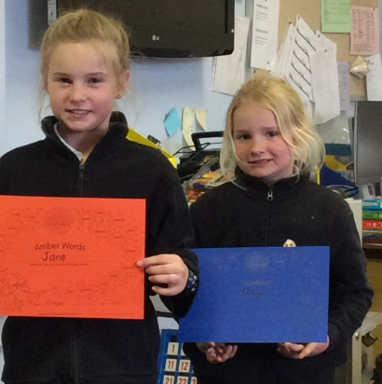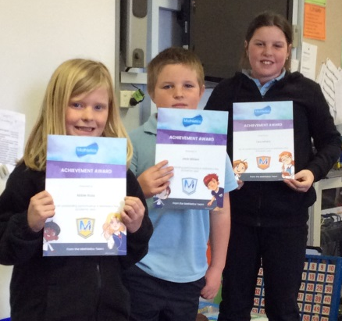

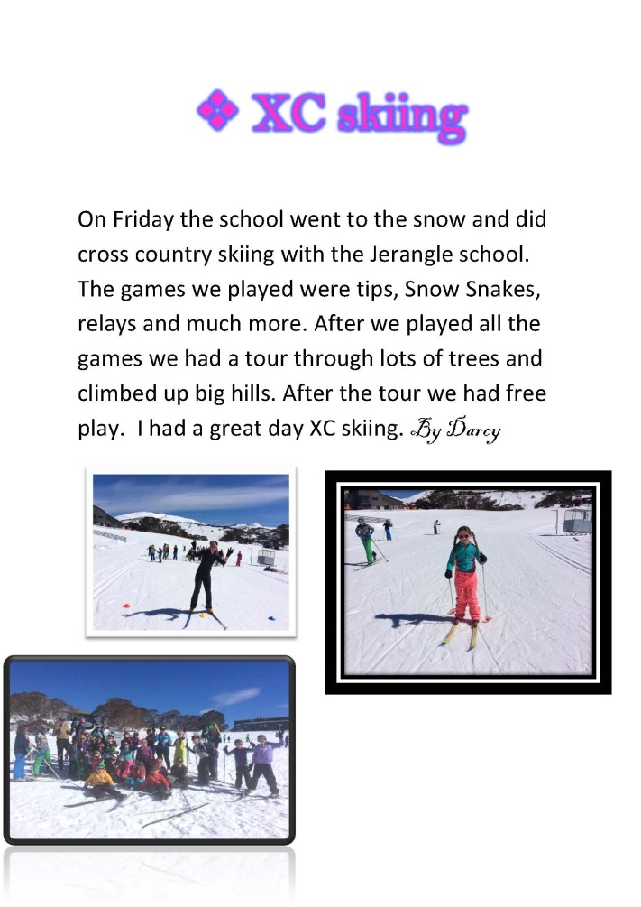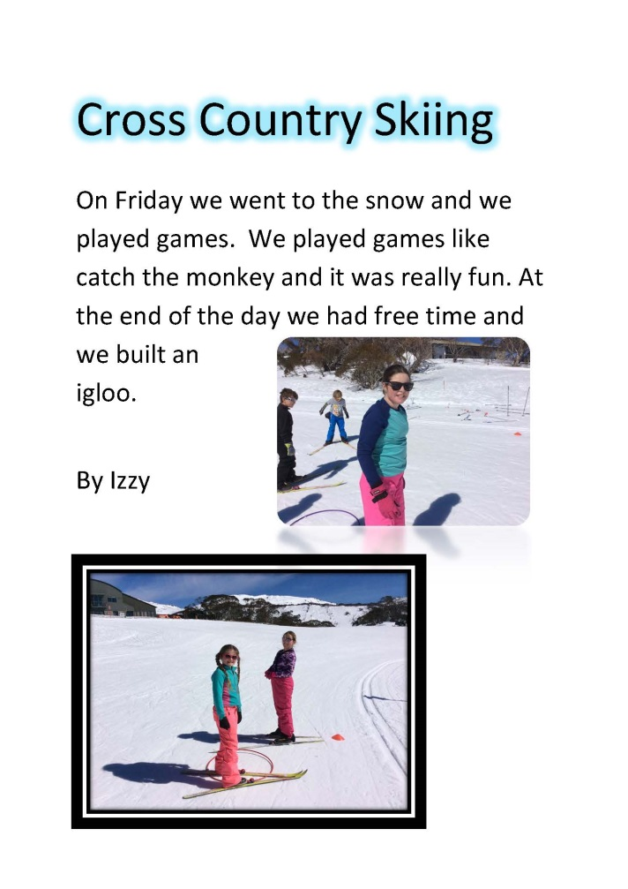

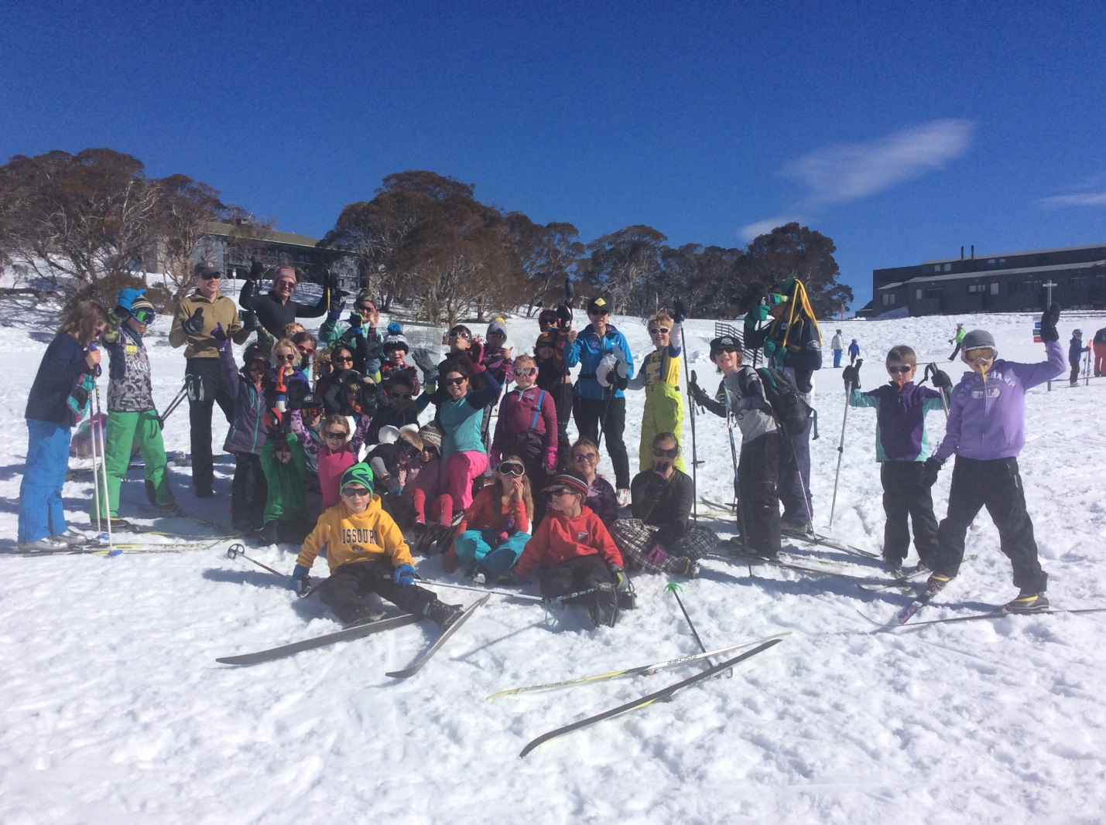

Cooma Champs Tennis

SCHOOL HOLIDAY TENNIS CAMPS

Camp 1 : Tues 26th Sept, 2017

Camp 2 : Tues 3rd Oct, 2017

9am – 3.30pm Jindabyne Bowling Club
1 Day Camp – $50.00
Payment to be received previous to commencement of camp please.
Please call Tom:0404838049
Lessons available during the school term in Jindabyne on a Friday afternoon. We would love to hear from you!!
TOM PEREA : ACCREDITED ATPCA / TENNIS AUSTRALIA CLUB PROFESSIONAL. ACTIVE AFTER SCHOOL ACCREDITED
Awesome prizes to be won!

